Narrative information
Taken from Educational Webinar Power Point- Slides 33

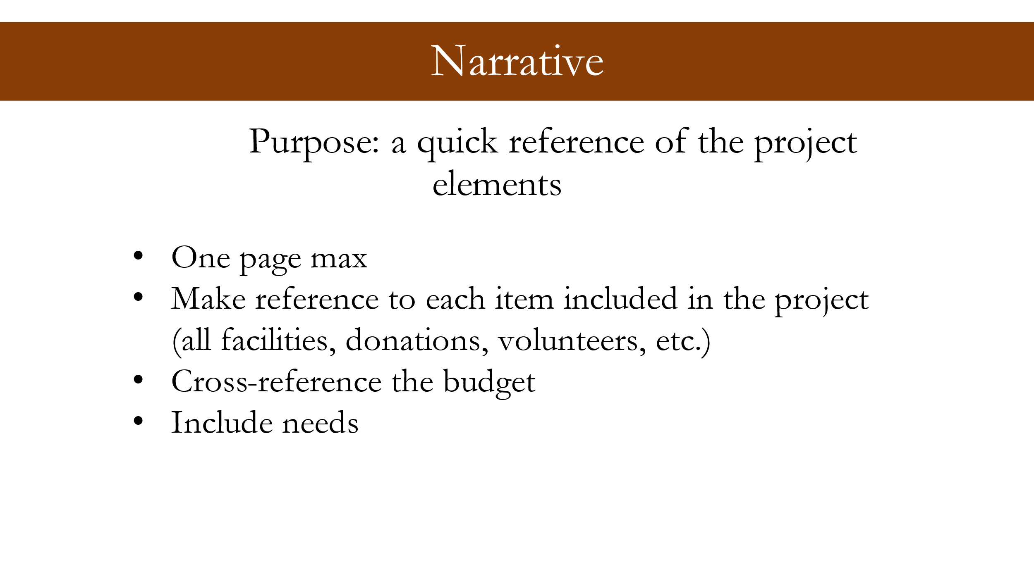

Example
Norfleet Park
Project Narrative

Background
The 40-acre Norfleet Park was developed in 1990. Current facilities at the park include: 1 football field; 4 baseball fields; a concessions/restroom building; paved parking; and a maintenance area. All fields are lighted.

Need
During the COVID crisis outdoor recreation became a focal point in people’s minds. As the only outlet, it became popular again and the popularity has not slowed down. We received many citizens comments over the last years that the facilities are nice but dated. We need to meet the needs of our existing and new users. Renovations at Norfleet Park will be completed in phases. Phase 1 was the replacement of all fencing and was completed in 2021.

Request
Phase 2 of the Norfleet Park renovation project will consist of demolition of the existing concessions/restroom building and construction of a new 2 story concessions/restroom building. The upper level of the building will be used for coaches’ meetings, umpire area and scorekeeping station.

